IBM Cloud Services

Create IBM Watson IoT Platform And Device

|  |  |
| --- | --- |
| Assignment Date | 8 November 2022 |
| Team ID | PNT2022TMID45278 |
| Project Name | Real-time river water quality monitoring and control system |
| Maximum Marks | 2 Marks |

REAL-TIME RIVER WATER QUALITY MONITORING AND

CONTROL SYSTEM

**Step 1:**

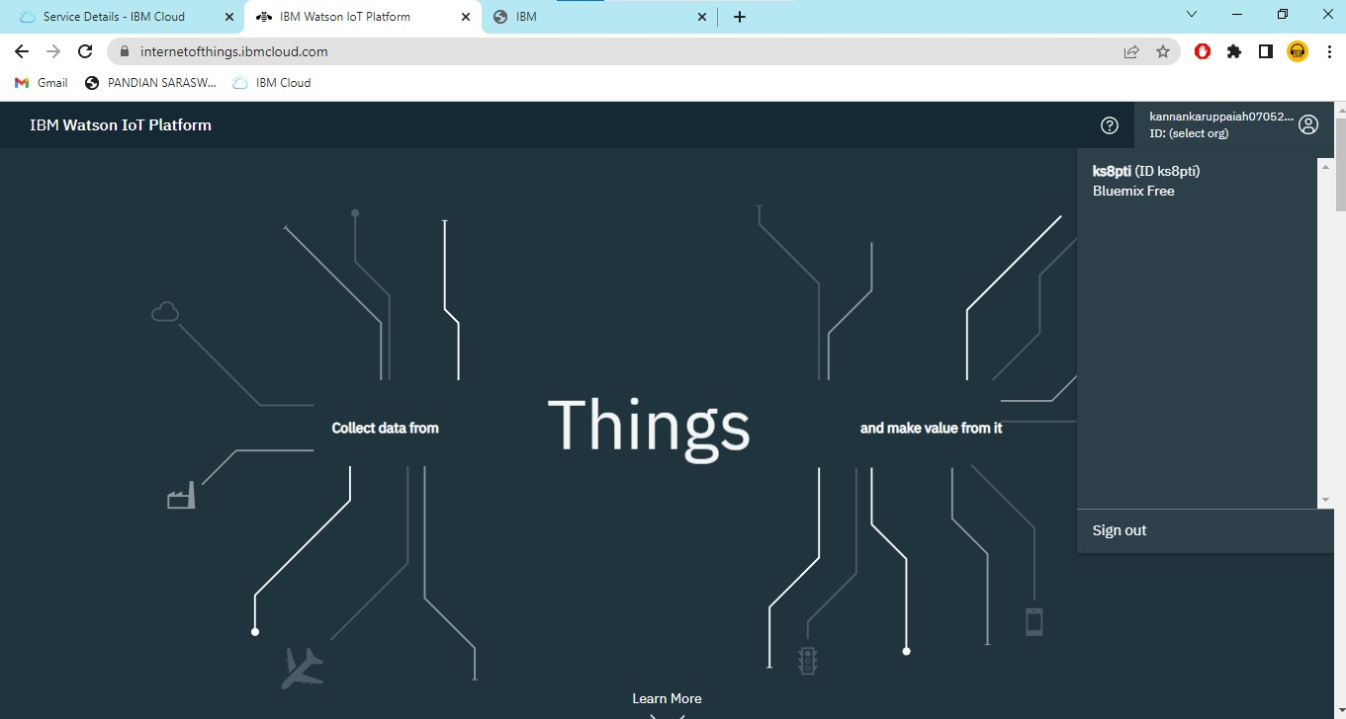

**Step 2:**

